Famous modern architects of the twentieth century.

Famous modern architects of the twentieth century found styles that were new, individual, unique and novel. As modern tastes changed, architects rejected classical styles and the lavish excesses of the Victorians and Edwardians. Modern architecture took the twentieth century in exciting new directions. The major architectural styles of the century are Modernism, Post-Modernism, High-Tech, Deconstructivism and Neo-Modernism. Many architects worked in more than one style during their career.
The dominant architectural style of the twentieth century was Modernism. The goal of Modernism was to free the human spirit, using technology that would make beauty and utility available to all. Shapes were abstract, geometric and unique. Floor plans were opened up for multipurpose use. Ornamentation and classical forms were discarded. Architecture was first and foremost about the individual.
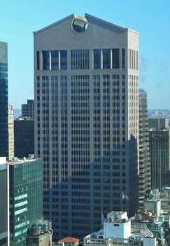
AT&T Building, New York (now Sony)
Architect Philip Johnson

Since 1980, architects have moved away from rectilinear forms to eclectic designs. Today's architecture embraces the wealth of unusual new materials and the power of computer-assisted design, CAD, to break from tradition. The new manifesto seems to be: Let's create original art. Let's have fun. Let's defy gravity with zany columns and walls. Let's design buildings that express irony and ambiguity. Let's explore glamorous new materials.
The practice of architecture is the most complicated of all the arts. It requires not only creativity, design skills and planning, but also knowledge of structures, materials, mechanics and engineering. Unlike other artists, the architect requires financing, client cooperation and years of effort to bring a project to completion. Architects have also embraced the need for "green buildings" with sustainable materials and energy conservation.

Famous Modern Architect Antoni Gaudi

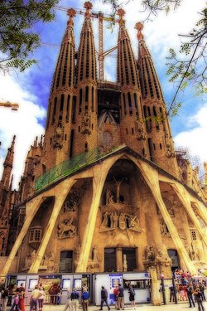
Church of La Sagrada Familia
Architect Antoni Gaudi

Famous architect Antoni Gaudi, (1852-1926), pronounced Gow DEE, was the most original architect of the Art Nouveau style. Art Nouveau, the new art, replaced straight lines with the free-form curves, wavy walls, and the textures and shapes of nature's plants and trees. His most important work, Casa Mila, is one of the outstanding buildings of Art Nouveau architecture. Gaudi began work on the Church of La Sagrada Familia, which resembles a surreal sandcastle or a clay sculpture, but he died before its completion. Seeing his imaginative work is the highlight of a trip to Barcelona, Spain.
Famous Modern Architect Eero Saarinen
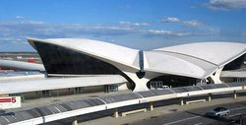
Architect Eero Saarinen
TWA Terminal, JFK Airport, New York

Architect Eero Saarinen (1910-1961), classified as a Neo-Expressionist, brought a sculptor's sensibility to his buildings. Neo-Expressionism architecture is modernist and abstract, but with romantic imagery and the intuitive shapes. Saarinen is best known for the TWA Terminal, JFK Airport, New York, where he captured the excitement of flight with giant wings of concrete. Other examples of the Neo-Expressionism style of architecture are the Sydney, Australia, Opera House, by Jorn Utzon, the work of Le Corbusier and Frank Lloyd Wright's Guggenheim Museum.

Famous Modern Architect Frank Lloyd Wright

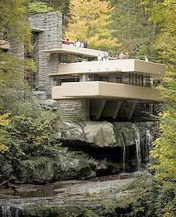
Fallingwater, Mill Run, Pennsylvania
Architect Frank Lloyd Wright
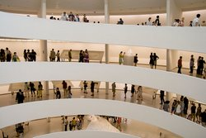
Guggenheim Museum, New York
Architect Frank Lloyd Wright

American architect Frank Lloyd Wright (1867-1959) is the most famous architect of the twentieth century and one of the most prolific. Wright defined his Prairie School style of architecture with organic buildings that extend the indoors to the outside. Prairie style houses cling to their site with low-slung projecting roofs that suggest security and shelter.

Inside, Wright used open, unobstructed floor plans so that space flowed from room to room. Wright often designed the interior fixtures and furniture, too. His authentic, democratic style was influenced by his famous mentor, architect Louis Sullivan. The first Pr airie House was the Robie House in Chicago. Fallingwater is Wright's most famous residence, a set of sweeping cantilevered planes anchored to the ledge above a spectacular waterfall. His final work, the famous Guggenheim Museum in New York, an example of Neo-Expressionism architecture, was completed just before his death. For the Guggenheim, Wright created a continuous, flowing space with a multi-floor spiral ramp, flooded with light from the sky dome. Several movies have been made about the life of Frank Lloyd Wright.
Famous Modern Architects of the Skyscraper

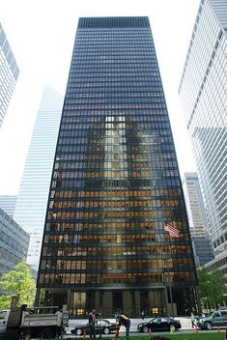
Seagram Building, New York
Architects Mies and Johnson

The skyscraper is a remarkable creation of twentieth century architecture. The skyscraper is a uniquely American style of architecture made possible by the invention of electric elevators and structural steel beams. These tall buildings make efficient use of the free air space over expensive land. So familiar is the skyscraper that we are no longer astonished by these architectural feats. Famous skyscrapers of the century are
- The Guaranty Building (1896) Buffalo, New York by Adler and Sullivan.
- The Woolworth Building (1913) New York, by Cass Gilbert, distinctive for its use of historic decorations and crowns.
- Chrysler Building (1930) by William Van Alen. In the Art Deco style, it has eagle gargoyles that look like hood ornaments.
- The Empire State Building (1931) New York, by Shreve, Lamb & Harmon. With 102 stories, the Empire State Building was the world's tallest building for 40 years.

- The Seagram Building (1958) New York, by Mies Van der Rohe and Johnson.
- The AT&T Building (1984) New York, by Philip Johnson and John Burgee. It is now called the Sony Building.
Famous Modern Architect Ludwig Mies Van Der Rohe

Farnsworth House, Plano, Illinois
Architect Ludwig Mies Van Der Rohe
German architect Ludwig Mies Van Der Rohe (1886-1969) summed up his design philosophy as "Less is more," and "God is in the details." Mies, along with Walter Gropius and Le Corbusier, is the pioneer of Modern architecture. He created this influential twentieth century architectural style based on the simple cube and flowing interior space with industrial steel and plate glass. His Modernist residence, The Farnsworth House (1950) in Plano, Illinois, is a National Historic Landmark. The design for Farnsworth House was reduced to the architectural minimum, unobstructed living space within four glass walls and steel I-beams on a concrete floor. Mies, collaborating with Philip Johnson, advanced architecture with the Seagram Building in New York (1958), a distinctive skyscraper of glass partitioned with exterior, bronzed, non-structural I-beams. Mies believed that Modernism, where the cube was king, gave order to the confusion of daily life.

Famous Modern Architect Le Corbusier

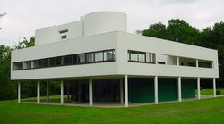
Villa Savoye, Poissy, France
Architect Le Corbusier
Famous Swiss architect Charles Edouad Jeannert (1887-1965) called himself Le Corbusier. He was a minimalist architect of the Modern movement who believed that architectural design could improve human nature. He had universal influence and is considered the "Picasso of architecture." His motto in French was "sunlight, space and greenery." Le Corbusier preferred a building without decoration, raw concrete raised on pillars, with long horizontal window strips, open floor plan and a roof garden.

His iconic landmark is Villa Savoye (1928), in Poissy, France. He also designed mass housing as a total environment for people, the Unite d'Habitation in Marseilles, France.
Famous Modern Architect Renzo Piano

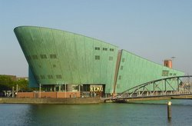
NEMO, Amsterdam
Architect Renzo Piano
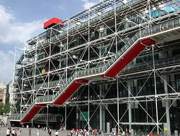
Centre Pompidou, Paris
Architect Renzo Piano & Others

Italian architect Renzo Piano (b.1937) and British architects Richard Rogers and Su Rogers desiged the the Centre Pompidou (1977) in Paris. A daring example of High-Tech architectural design, the museum and library building uses the brightly-colored tubes for wiring and plumbing as part of its decoration. It looks as if Piano and Rogers build the structure inside out. Renzo Piano also designed NEMO, The New Metropolis (1997), a science center in Amsterdam that resembles a supertanker in oxidized copper. In 2007 Rogers won the prestigious Pritzker Prize, which is called the Nobel Prize of architecture.

Famous Modern Architect Philip Johnson

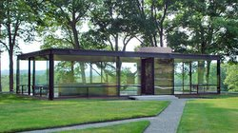
Glass House, Connecticut
Architect Philip Johnson

American architect Philip Johnson (1906-2005) is the architect who embraced all the twentieth century movements, one after the other. In his Modernist period he is most famous for the minimalist Glass House (1949) in New Canaan, Connecticut. He collaborated with Mies Van Der Rohe on the Seagram Building (1956). Many of his works became instant icons, such as PPG Place in Pittsburgh and the landmark Crystal Cathedral in Garden Grove, California. The AT&T Building, with its neo-Georgian, Chippendale style pediment, is a famous work of Johnson's Post-Modern period. Philip Johnson was awarded the first Pritzker Architecture Prize in 1979.
Famous Modern Architect I.M. Pei

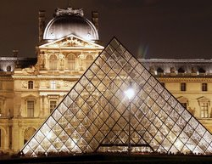
Architect I.M. Pei
Pyramid Entrance to the Louvre
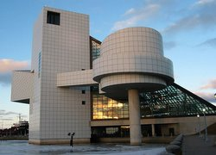
Rock & Roll Hall of Fame, Cleveland
Architect I.M. Pei

The Chinese-American architect I.M. Pei (b.1917) is one of the best-known architects. He is particularly identified with his use of the glass pyramid. His work includes the East Wing of the National Gallery of Art, the Rock and Roll Hall of Fame, the Bank of China Tower in Hong Kong and the Miho Museum in Kyoto. The most controversial of his works is at the Louvre Museum in Paris, where he designed the 71-foot glass pyramid as the new underground entrance to the museum. (Pictured above) Sitting in the center of the plaza, Pei's pyramid contrasts provocatively with the massive historical stone buildings of the Louvre. Among the many awards he received is the Pritzker Prize.
Famous Modern Architect Frank Gehry

Residence of Architect Frank Gehry
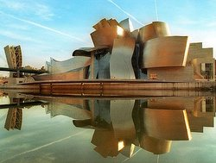
Guggenheim Museum, Bilbao, Spain
Architect Frank Gehry

Architect Frank Gehry (b. 1929) is an original and creative Canadian-American architect who designs buildings as sculpture, so that the form of the building stands as a work of art on its own merits. The Guggenheim Museum in Bilboa Spain (1997) is called the greatest building of our time. In it Gehry used a set of rolling titanium shapes that convey meaning and significance to the viewer. Among his architectural masterpieces is Walt Disney Concert Hall in Los Angeles, pictured above. Gehry's personal residence in Santa Monica, with its eclectic collage of plywood, corrugated metal, chain link fence and asphalt, is an example of the Deconstructivism style of architecture.
Famous Women Architects

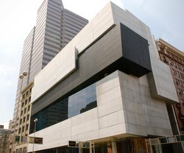
Contemporary Art Center, Cincinnati
Architect Zaha Hadid

Famous women architects have recently excelled in their profession. Even during the twentieth century, women were often refused admission to architectural schools and had difficulty finding clients. Julia Morgan (1872-1957), the first woman accepted at the Ecole des Beaux-Arts, is best known as the architect of the magnificent Hearst Castle, San Simeon, California. Iraqi architect Zaha Hadid designed the Contemporary Arts Center (2003) in Cincinnati, Ohio, as a rolling urban carpet. The New York Times called it "The most important American building to be completed since the end of the cold war." Other famous women architects are Gae Aulenti, Itsuko Hasegawa, Margaret McCurry and Denise Scott Brown.

