Beineu Lyceum

Open lesson plan
Theme: “The geographical position of the USA ”

Teacher: Kozybakova I.A

2016-2017a.y
Date:
Grade: 8th
Theme: The geographical position of the USA
Aims:
- To give information about America; to teach correct usage of article with geographical names; to practice and doing exercises;
- To develop pupils’ skills;
- To bring up them to love Motherland and to respect other nations and its traditions;
Aids: slides, posters, cards

The procedure of the lesson
- Organization moment.
- Dividing class into 2 groups.
- Warm –up
- Checking up the home task. Method “Noughts and crosses”
- New theme. The discovery of America
- Poster
- Magic box. New word.

Canyon – каньон, шатқал
Waterfall - сарқырама
Cave – үңгір
Peak - шың
Lowland – ойпат

- Work with the text. Read and translate.

- What do you know about America?

- Brush up your grammar
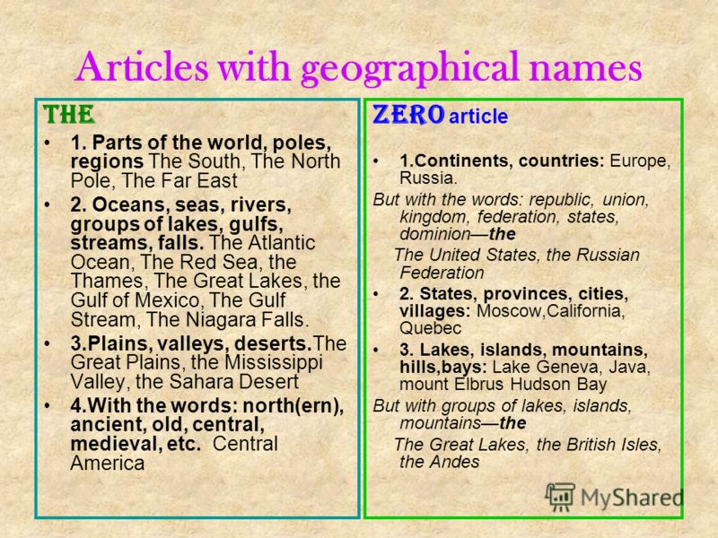
- Doing exercises.
- Conclusion.
- Feedback.

