Урок английского языка в 5ом классе по учебнику «Forward» на тему «Зимние праздники на Руси и в англо-говорящих странах».

Цель: активизация навыков монологической и диалогической речи, отработка грамматических навыков, развитие языковой догадки, мультикультурных интересов.

Языковой материал: лексика по теме
Оборудование: учебник «Forward» для 5ого класса под редакцией М.В. Вербицкой, разделы 11,12.

Warming up :
People all over the world like to celebrate holidays. Some of them are public , others religious ones.
- What winter and spring holidays do people celebrate in Russia?
- What English winter and spring holidays do you know?

Ход урока
- There are many festivals shared by people all over the world.
One of them is known by the name Maslenitsa in Russia , Fat Tuesday in the USA, Pancake day in England.
The holiday is pagan in origin : people eat rich fatty food before fasting during the season of Lent.
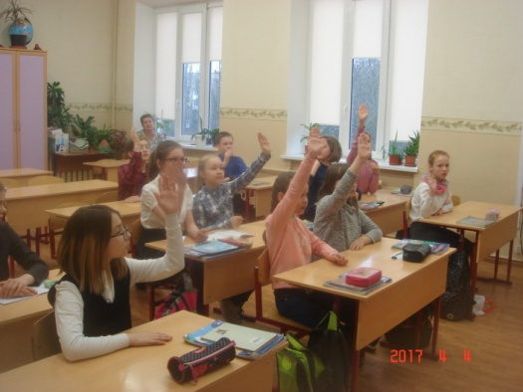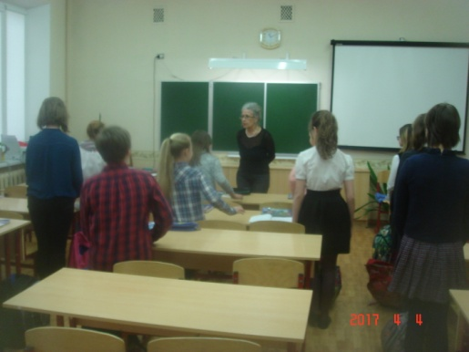

- First of all let’s repeat some useful words and expressions .
- What’s the English for…. Spell it, please.( N! Come to the blackboard and write letters B. spells)
Слова : празднество /фестиваль, блин, сковорода , языческий, религиозный , Великий пост , поститься , захват снежной крепости , катание на санках, катание на тройках, перетягивание каната ,чучело Масленицы , фартук , подбрасывать.
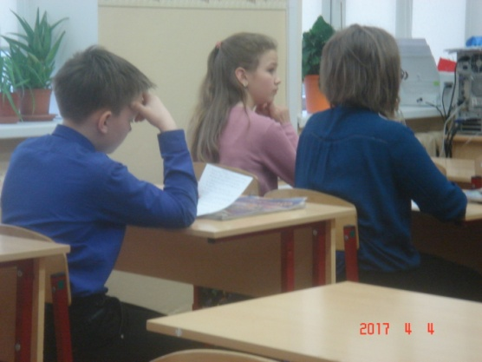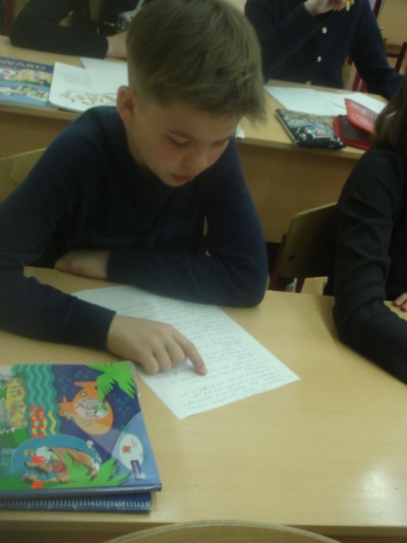

- One of the funniest winter festivals is Maslenitsa
Answer my questions :
- What are the most popular festive activities ?
- How long is it? When does it begin ? and end?
- What does it symbolize /signal?
- How does the week end? What do they burn?
- Why are blini very important in the celebration of Maslenitsa? What are they symbol of ?

- Now let’s repeat a bit of grammar .
Мы закончили 3 четверть изучением Страдательного залога (Passive Voice).Какова формула Страдательного залога(Passive Voice) ?

To be + 3 ф. гл.
На доске
Am ,Is, Are - Was /were
Will be
- Раскройте скобки , употребите глаголы в Страдательном залоге.
1.Pancakes (to make ) from milk and eggs.
2.In England pancake races are( to held) all over the country.
3.Pancakes must (to toss) 3times.
4.The student (to invite) to the pаncake race next week.
5.Pancakes (to give) to friends and the family all through the week.
6. The biggest pаncake( to cook)in England.
7. Fat Tuesday (to celebrate) in many countries of the world.
VI . Переведите предложении я в Страдательный залог.
1.Russians eat blini with jam, sour cream, hоney and butter.
2.People eat rich fatty food before Lent.
3.Boys and men bring flowers to girls and wоmen.
4.Men do all the housework on Women’ day.
5.In Britain people celebrate Mother’day 3 weeks before Easter.
6.Mothers colour eggs for Easter.
7.Men and women put on aprons before pancake race.
VII. Арина и Даша приготовили кроссворд.
(Решение кроссворда.)
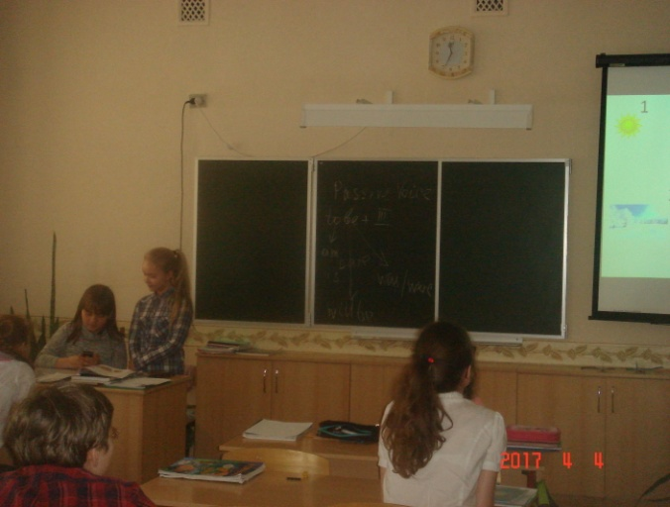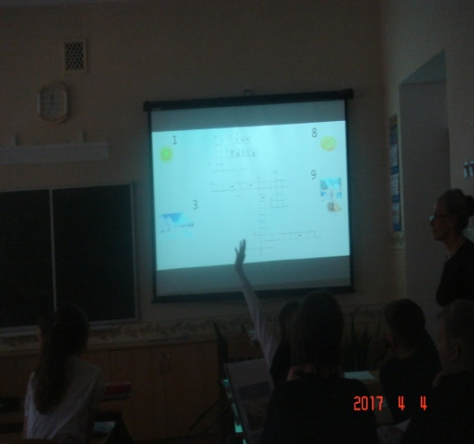
VIII. What are the rules of а pancake raсe? Let’s compete.

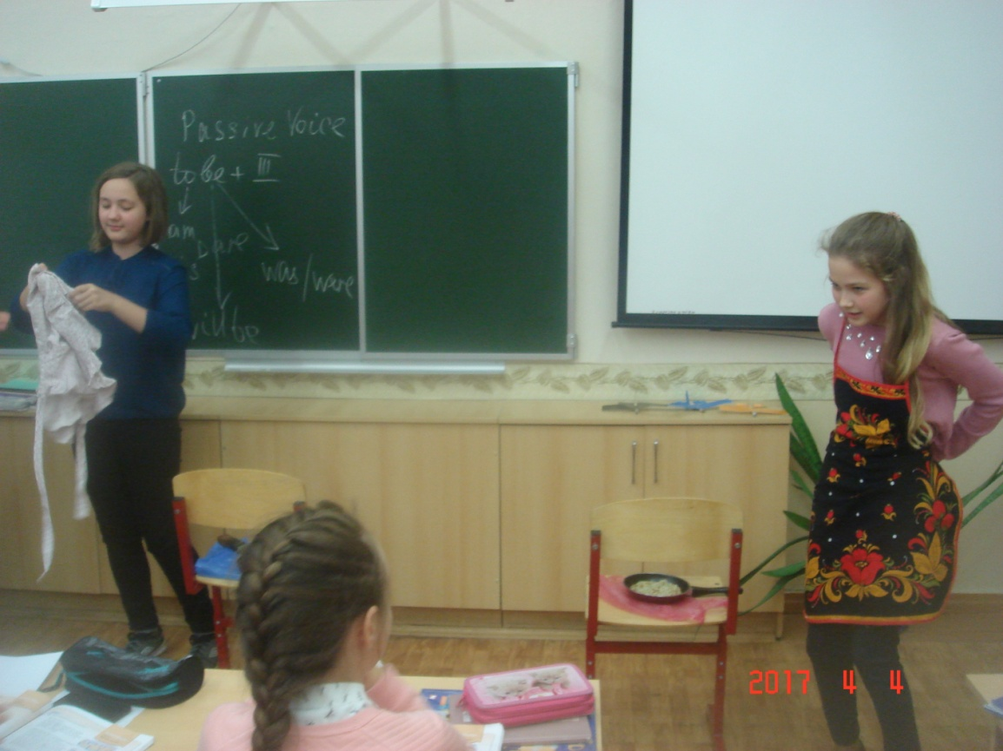
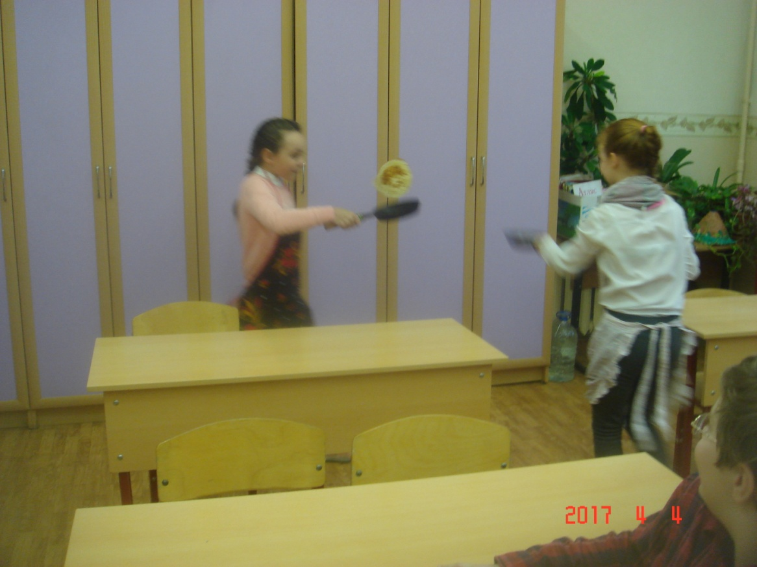
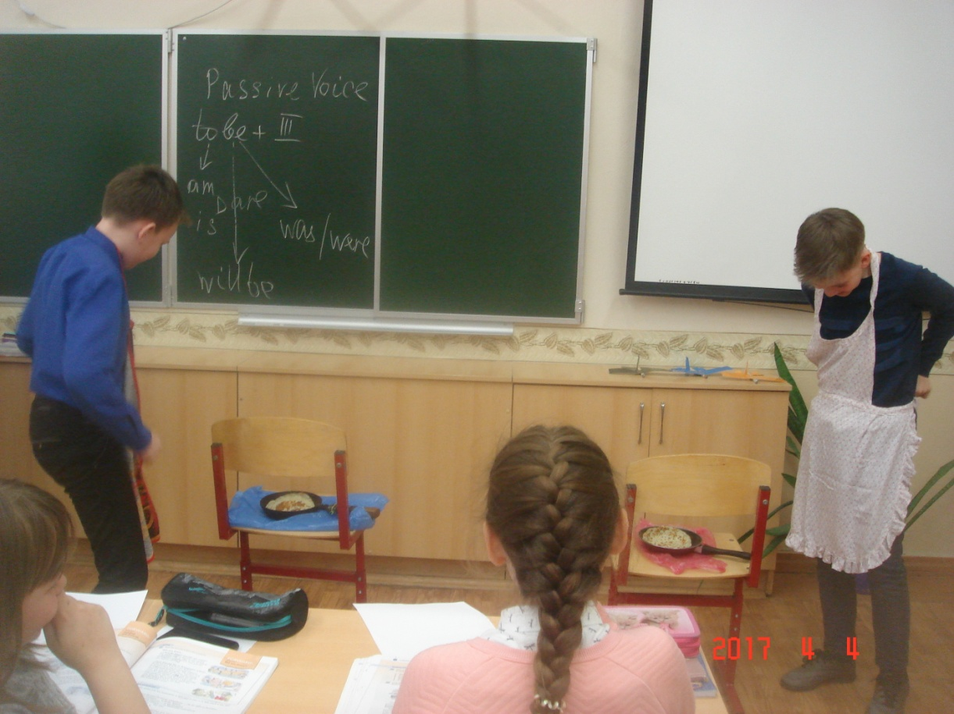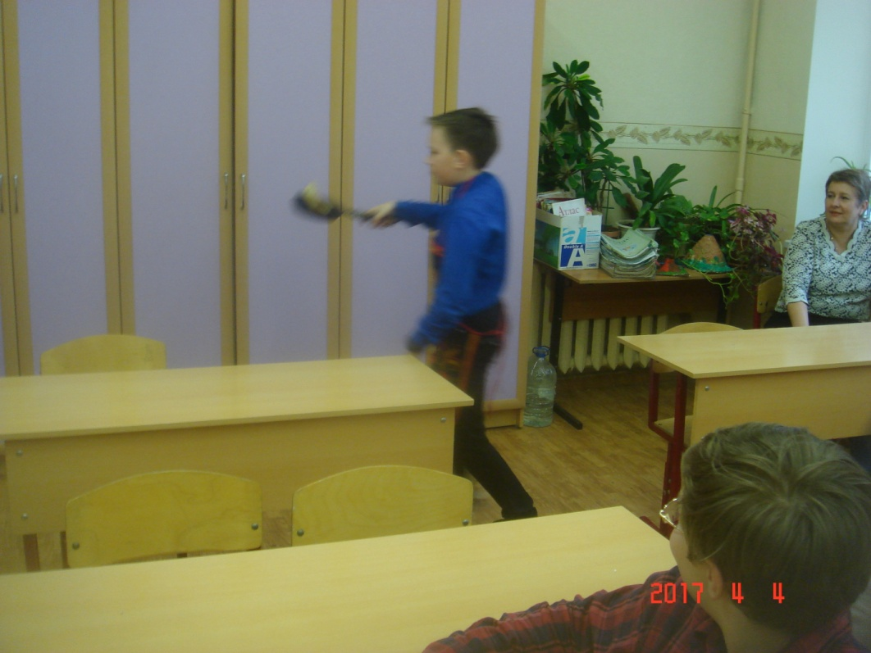
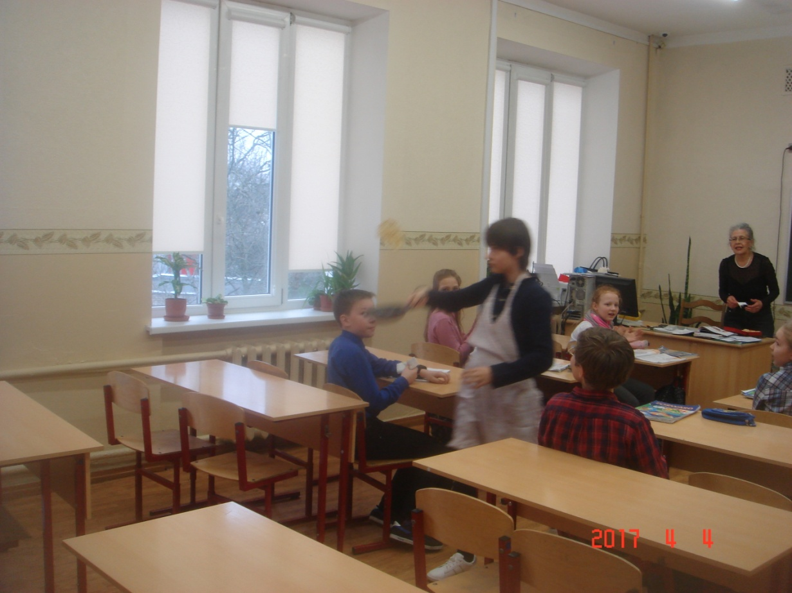
IX. Now we’ll try to make dialogues. One of you is from Great Britain, the other from Russia. You would like to know more about Maslenitsa and Pancake Day (Fat Tuesday) [Работаем в парах]
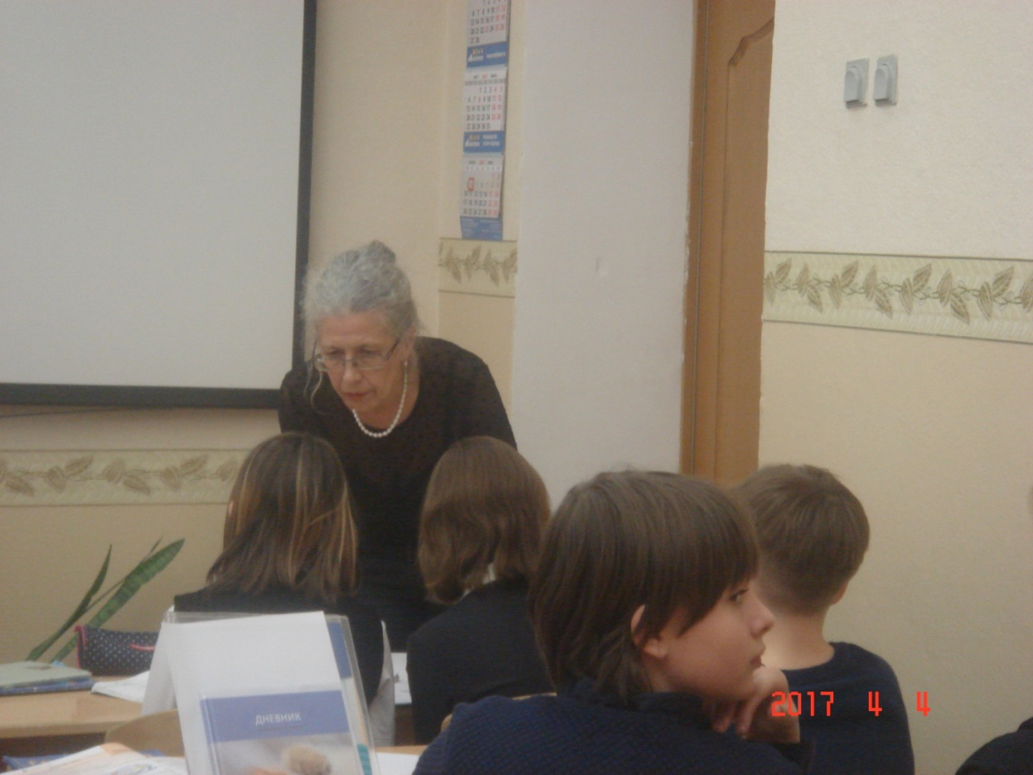
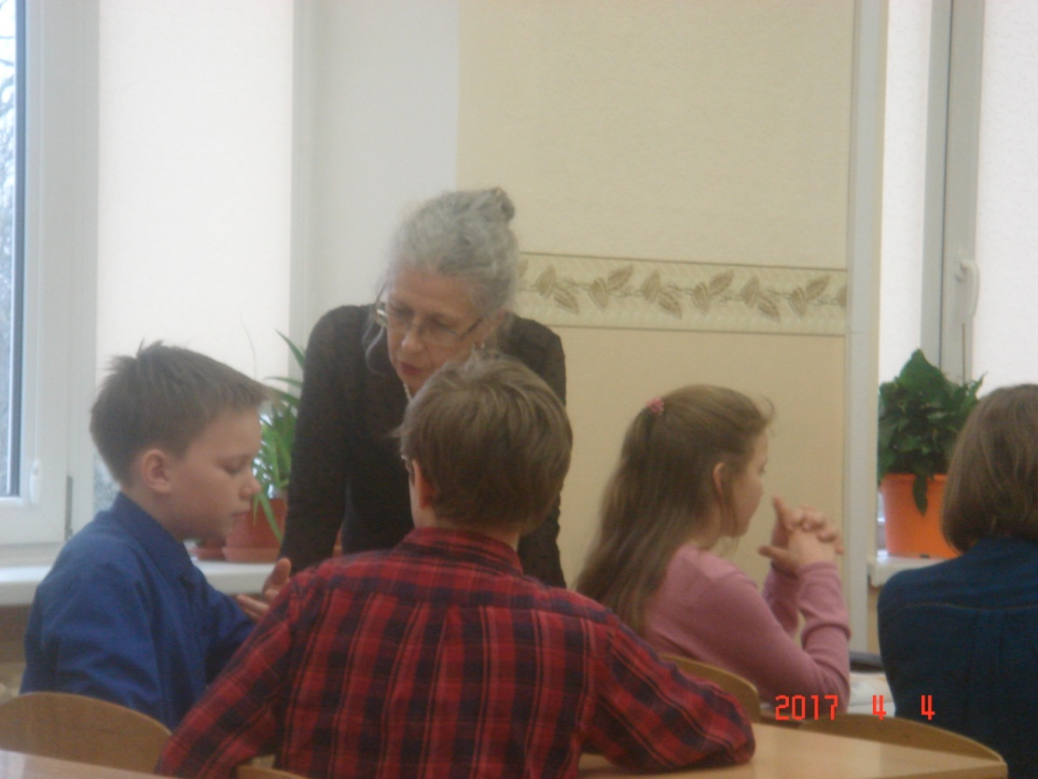
IX.Подведение итогов.
Thank you everybody.

