Поурочный план
Предмет: Английский язык
Класс: 5 «А»
Дата: 29.01.2016
Учитель: Подлесная Ольга Николаевна
Тема: “Would you like..”construction. Eating out ».
Цель занятия: изучить и закрепить использование конструкции “Would you like...” при выполнении практических заданий.
Задачи урока:
1. Образовательная – обеспечить использование активной лексики по теме "Еда" в рамках учебной ситуации "В кафе"; познакомить учащихся со структурой would like и научить применять ее в заданной ситуации.
2. Воспитательная – способствовать формированию коммуникативных навыков у школьников.
3. Развивающая – способствовать развитию у учащихся речевых навыков, внимания, мыслительных процессов (выделение существенного, соотнесение зрительного образа предмета с его лексическим значением)

Оборудование: мультимедиа-проектор, презентация Power Point, компьютер.
Раздаточный материал: карточки с заданиями.

Ход урока:

I. The beginning of the lesson.
T: Good morning, smiling faces. How are you? Well?! I hope we'll have a wonderful time together. Let's begin our lesson and first the phonetic drill:

II. Phonetic drill (на доске записана пословица: The appetite comes with eating.)
T: 1) Children, read the proverb and try to give Russian equivalent.
2) Say after me (отрабатывается произношение).
3)Try to learn the proverb (дети хором читают пословицу, с каждым новым повторением учитель стирает по одному слову, пока пословица не исчезнет).
4) Remember the proverb (несколько учеников воспроизводят пословицу).
T: Well done.

III. Introducing into the topic.
Т: Today we’ll talk about food. And the topic of the lesson is eating out (учитель показывает на доску, дает перевод). Children, answer some questions:
Do people usually eat at home?
Can people eat in a restaurant?
Can they eat in Mс Donald’s?
Can they eat in a pub?
And now look at the blackboard, please. There is a tasty crossword on it. If you do it right, you'll know where you are going today.
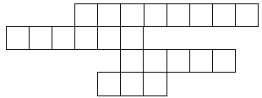
1. It's green and you have it in salad (cucumber).
2. Monkeys like the yellow fruit (banana).
3. Apples, bananas, plums are ... (fruit).
4. It's a drink. In Kazakhstan people usually drink it hot, but in some countries people drink it cold (tea).
Написав правильно слова по горизонтали, по вертикали появляется слово cafe.
Well, children. It's the place where we are going today.

IV. Explanation new theme.

Would You Like..?

Would you like + noun
How to use "would like" with a noun?
"Would like" has the meaning of "want", but it is used for more polite expressions.
- Do you want some coffee? ( This is less formal and polite. We usually use this for friends, children, and etc.)
- Would you like some coffee? (This is more polite and formal.)
We can use it with a noun:
Form: Subject + would like + noun
- I would like a glass of cola.
- Would you like some water?
- She would like a piece of cake.
We can use it in positive, negative sentences and questions.
- I would like some coffee.
- She would like a new pair of shoes.
- Would you like some water?
- Would you like an apple?
- He wouldn't like a sandwich.
- Mary wouldn't like an ice -cream.
"Would like" is the same for all subjects.
- I would like some soup.
- You would like some soup.
- He / she / James would like some soup.
- We would like some soup.
- They / our friends would like some soup.
Contractions:
We can make them shorter by using contractions:
I would like = I'd like
She would like = She'd like /he'd
They would like = They'd like
We would like = We'd like
You would like = You'd like
Example Sentences:
- I'd like some milk.
- I'd like some olives.
- I'd like some eggs.
- I'd like some bread.

V. Practical exercises.
Open your Class Books at page number 60.
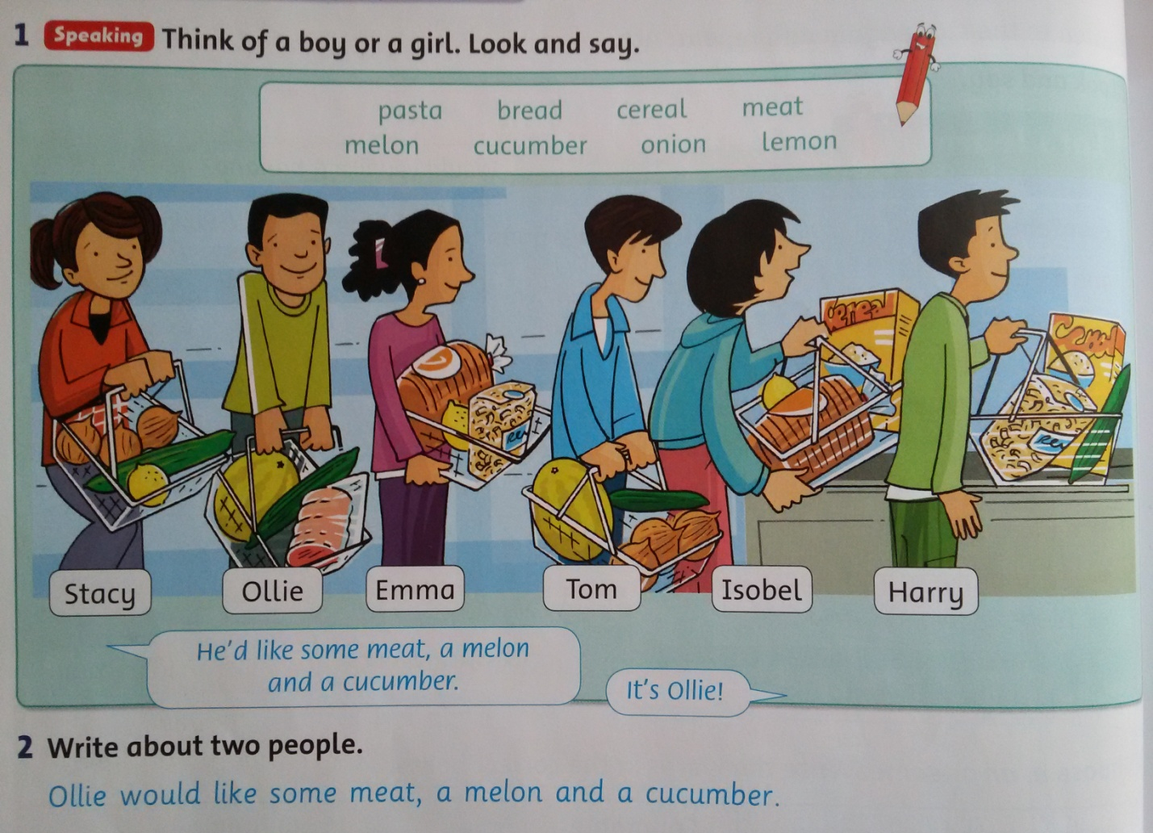
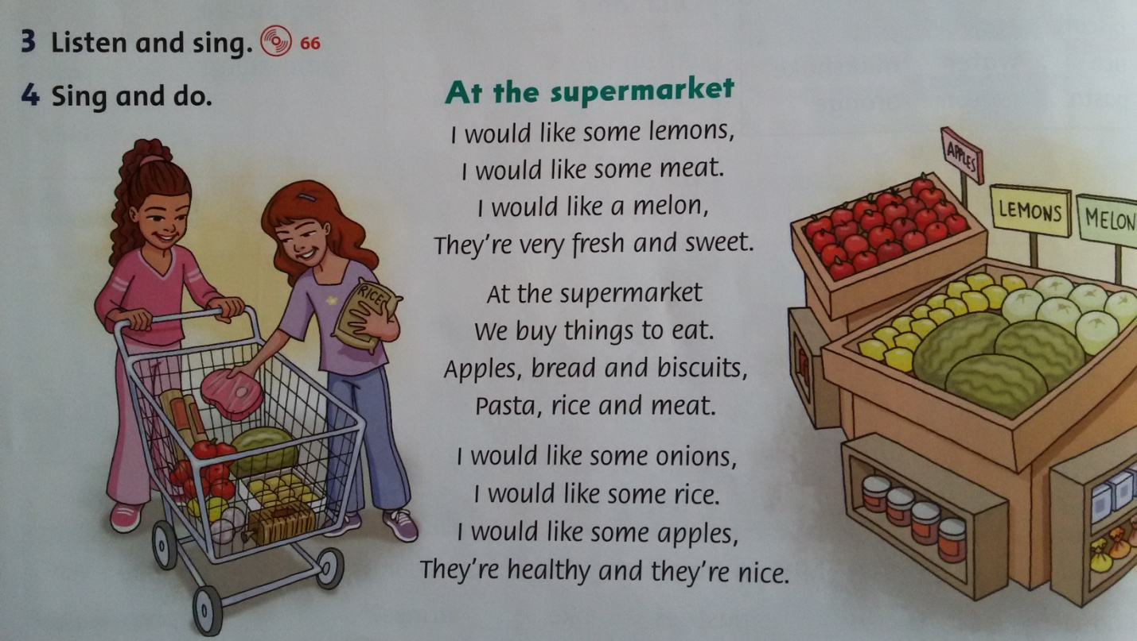

V. Unscramble the sentence.
6-would/ she/ to/ like/ go/ vacation/ on/ this/ year.
would to
7-like/ He/ meet/ wouldn't/ to/ you/ like.
He
8-love/ We/ to/ you/ visit/ would/ again.
We
9-play/ the/ guitar/ Would/ you/ like/ to/ ?
you
10-wouldn't/ to/ swim/ there/ I/ like.
I

VI. Open your workbook at page number 55.
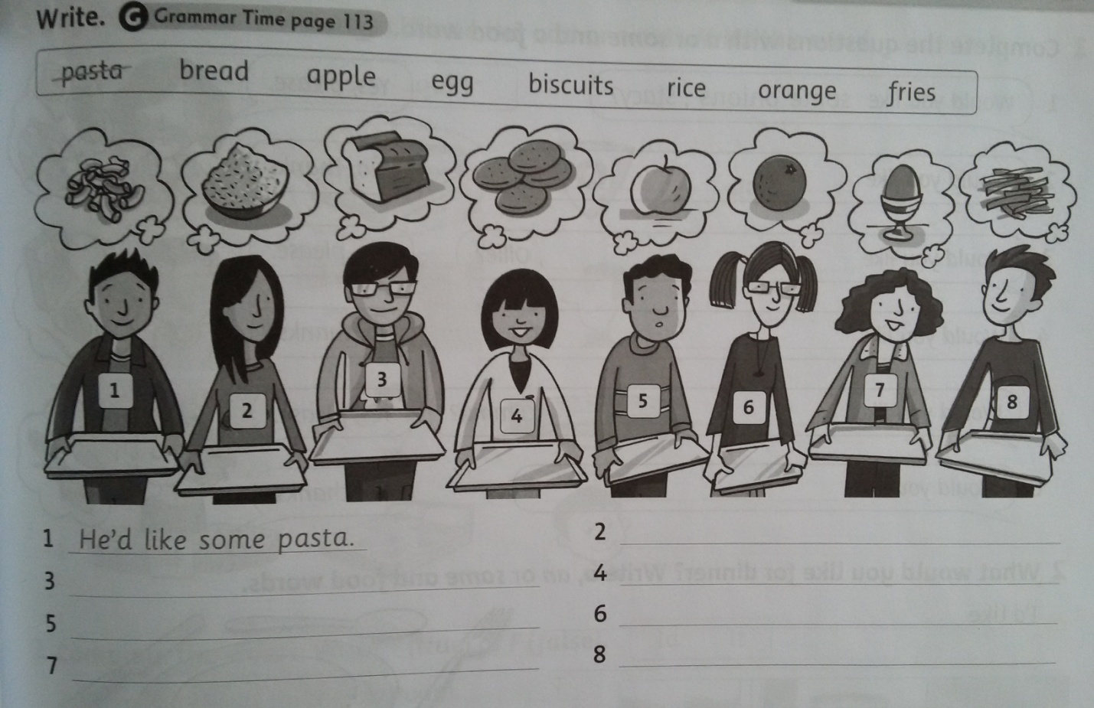

VII.
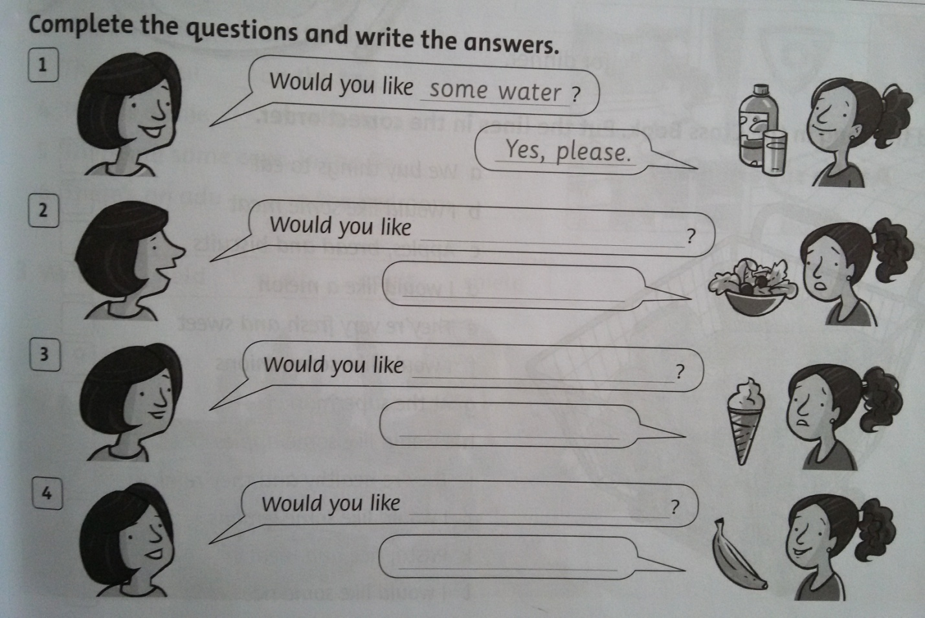
VIII. Find as much as possible words.
A | S | J | U | I | C | E | E
F | R | A | J | E | T | R | Y
A | P | P | L | E | R | B | T
S | O | W | T | R | K | W | W
W | O | R | A | N | G | E | C
E | A | M | M | A | J | L | O
E | R | Q | P | F | D | N | L
T | T | Y | E | N | C | V | A

Key: juice, apple, sweet, orange, cola.
IX. Distribute words in 3 columns - What people eat for breakfast, for a lunch and for a dinner?
Breakfast Lunch Dinner
…… ……. ……
шоколад chocolate
мороженое ice cream
йогурт yoghurt
пудинг pudding
пирог pie
пирожное cake
торт tart
чупа-чупс lollipop
конфета sweet
булочка roll
варенье jam
кока-кола coke
сок juice
лимонад lemonade
минеральная вода mineral water

Keys:
Breakfast Lunch Dinner
milk eggs yoghurt
toast juice bananas
ham salad cheese
soup cake fish
potatoes carrots

X. Useing “I would like…” construction, say what do you want to order from menu?

Pizza
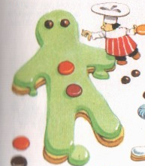
Choco Pie
Fruit Salad
Ice Cream
Chocolate
Lollipop
Sweet
Yoghurt
Tea 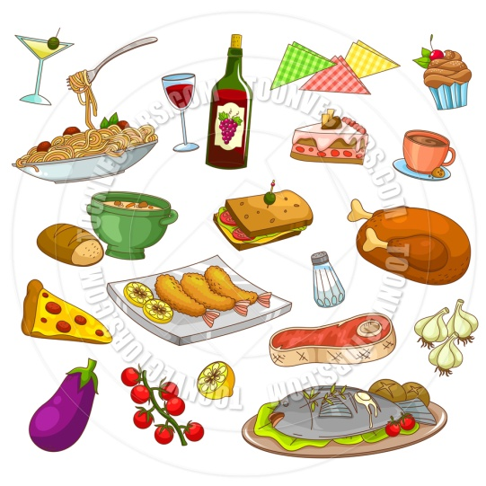
Orange Juice
Pineapple Juice
Mineral Water
Example:
In the café.
Ann: What would you like, my friends? As for me, I would like an ice cream and a glass of orange juice.
Mike: I would like an ice cream, a lollipop and a glass of orange juice.
John: And I would like a cake, a bar of chocolate and a glass of mineral water.
Helen: I would like yoghurt and a glass of orange juice.
Ann: We would like two ice creams, three glasses of orange juice, a lollipop, a cake, a bar of chocolate, one yoghurt and a glass of mineral water.

XI. Finish this text, entering the words represented on pictures.
In the Smiths' kitchen.
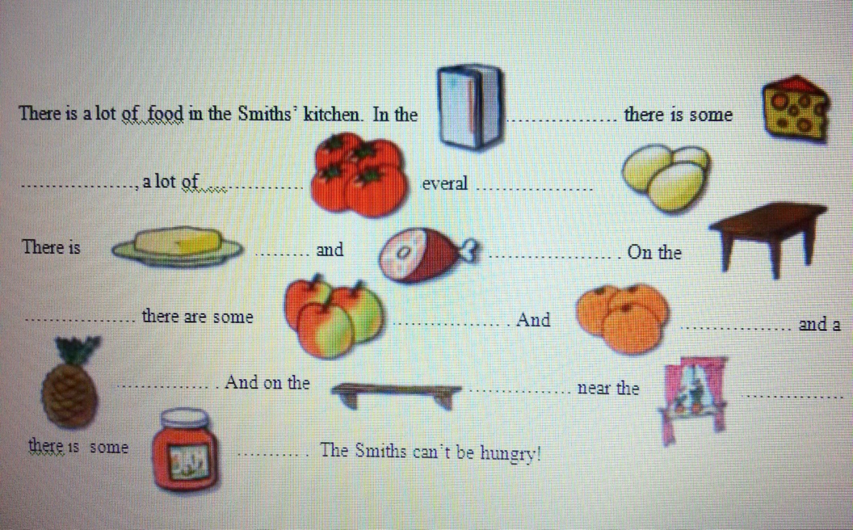

XII. Find as much as possible words.

juicetoastorangerollpietartsweetjamchocolatelollipopyoghurtpuddingcheesecarrot

XIII. Homework.
Workbook – p.56, Ex. 1-3.
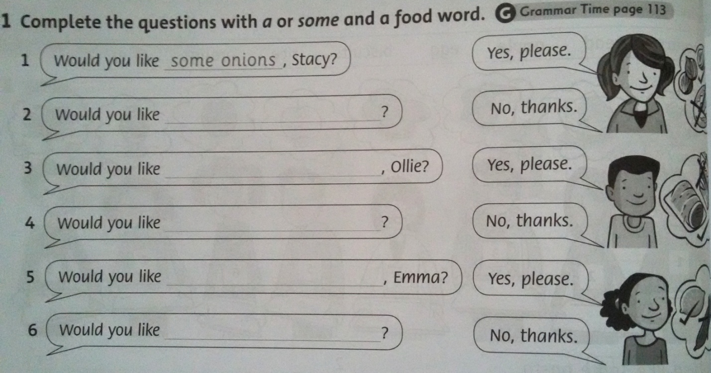
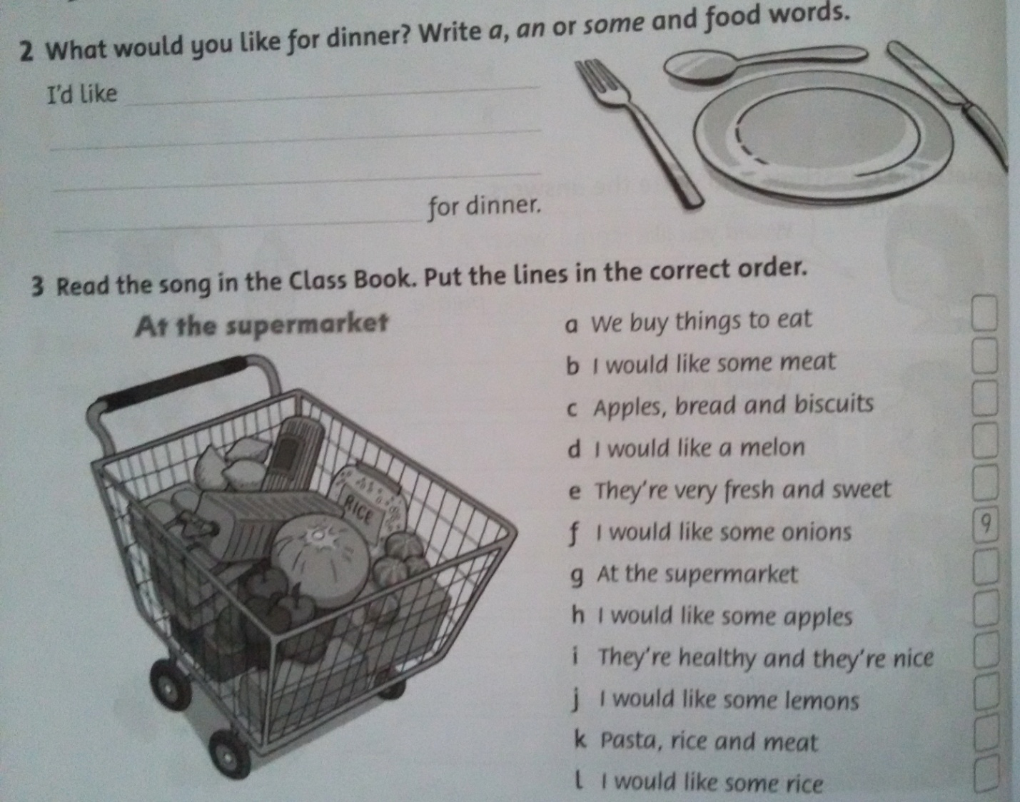

XIV. Reflection.
На доске вывешиваются 2 конверта – один для тех, кому понравился урок, другой – кому нет. Ребята подходят и кладут своё сердечко, вырезанное из бумаги в любой из конвертов.
XV. Marks for the lesson.
Children! You work very hard, I’m pleased with you work today. Our lesson is over.Good-bye!

